**CASSANDRA AGGREGATE FUNCTIONS**

Creating table

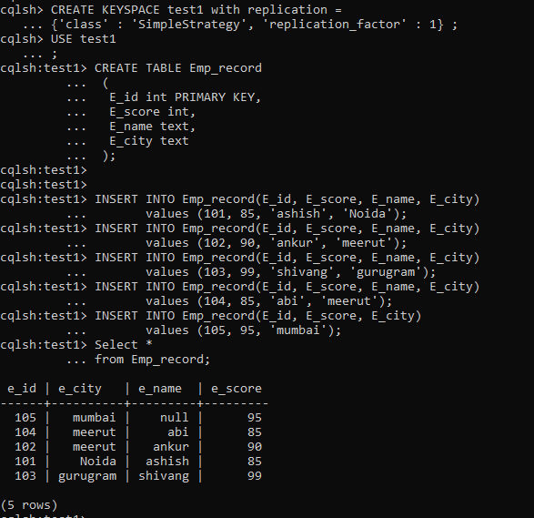

**Count**

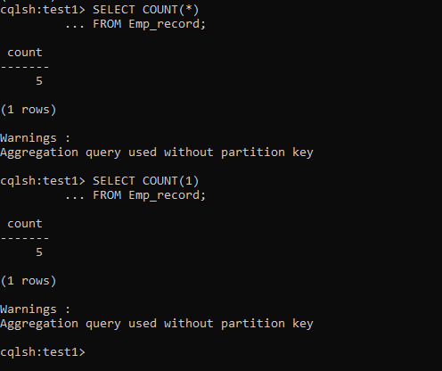

**MIN MAX**

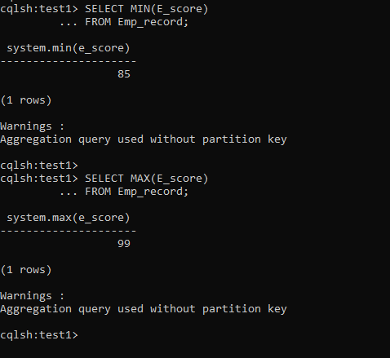

SUM

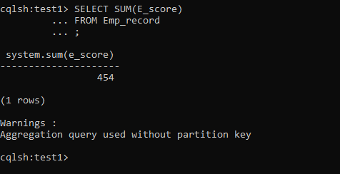

AVERAGE

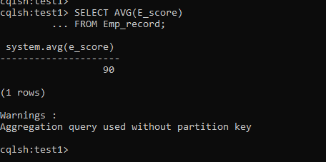

**CODES**

CREATE KEYSPACE test1 with replication =

{'class' : 'SimpleStrategy', 'replication_factor' : 1} ;

USE test1;

CREATE TABLE Emp_record

(

E_id int PRIMARY KEY,

E_score int,

E_name text,

E_city text

);

INSERT INTO Emp_record(E_id, E_score, E_name, E_city)

values (101, 85, 'ashish', 'Noida');

INSERT INTO Emp_record(E_id, E_score, E_name, E_city)

values (102, 90, 'ankur', 'meerut');

INSERT INTO Emp_record(E_id, E_score, E_name, E_city)

values (103, 99, 'shivang', 'gurugram');

INSERT INTO Emp_record(E_id, E_score, E_name, E_city)

values (104, 85, 'abi', 'meerut');

INSERT INTO Emp_record(E_id, E_score, E_city)

values (105, 95, 'mumbai');

Select *

from Emp_record;

SELECT COUNT(*)

FROM Emp_record;

Alternatively, To get the same result we can use COUNT(1).

SELECT COUNT(1)

FROM Emp_record;

SELECT MIN(E_score)

FROM Emp_record;

SELECT MAX(E_score)

FROM Emp_record;

SELECT SUM(E_score)

FROM Emp_record;

SELECT AVG(E_score)

FROM Emp_record;